2026 Lung Cancer Awareness Month

Sample posts – use these or create your own

 | They served our country. Let’s help protect their health. 🇺🇸  Veterans face higher lung cancer risk from burn pits, asbestos, and other military exposures. The good news: low-dose CT screening is available through the VA, and early detection saves lives.  This Lung Cancer Awareness Month, we’re joining Lung Cancer Foundation of America to help more Veterans get screened. Learn more and check eligibility: lcfamerica.org  #LungCancerAwarenessMonth #BreathOfHonor #VeteransHealth #LungCancerScreening #EarlyDetection
 | 10–15 minutes. No needles. Potentially life-saving. 🇺🇸  Lung cancer screening is simple and fast, and it can find cancer early, when treatment works best. Veterans, this Lung Cancer Awareness Month, talk to your VA care team about low-dose CT screening.  Not sure if you qualify? Take a quick eligibility check from Lung Cancer Foundation of America: lcfamerica.org  #LungCancerAwarenessMonth #BreathOfHonor #VeteransHealth #LungCancerScreening #EarlyDetection
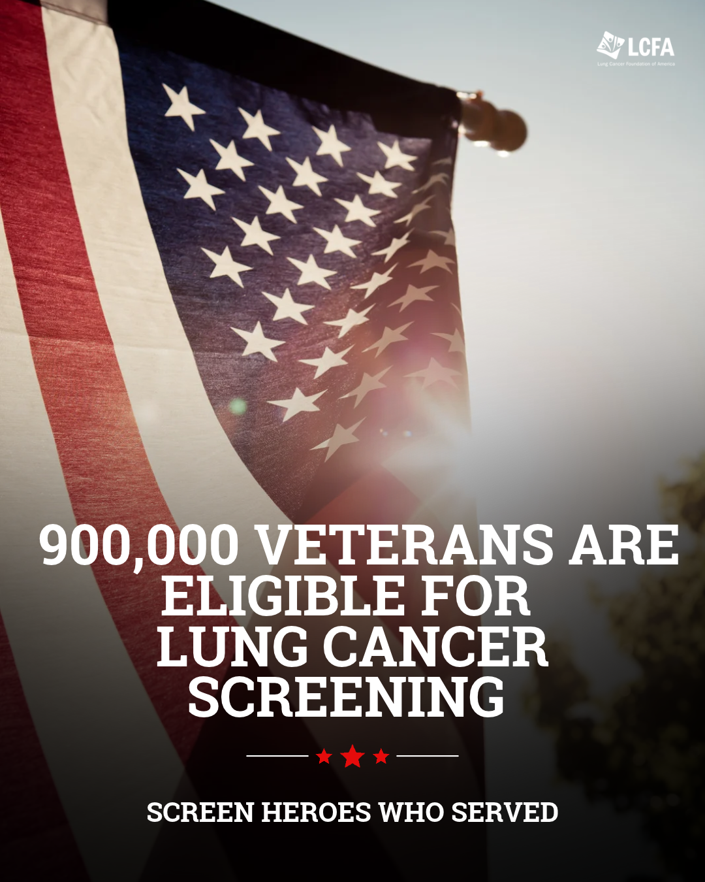 | 🇺🇸 Did you know an estimated 900,000 Veterans are eligible for lung cancer screening?  Early detection can make all the difference, but screening only helps if people know it’s available. This Lung Cancer Awareness Month, we’re joining Lung Cancer Foundation of America to help more Veterans get the potentially life-saving screening they’ve earned. 🎗️  Learn more and check eligibility: lcfamerica.org  #LungCancerAwarenessMonth #BreathOfHonor #VeteransHealth #LungCancerScreening #EarlyDetection
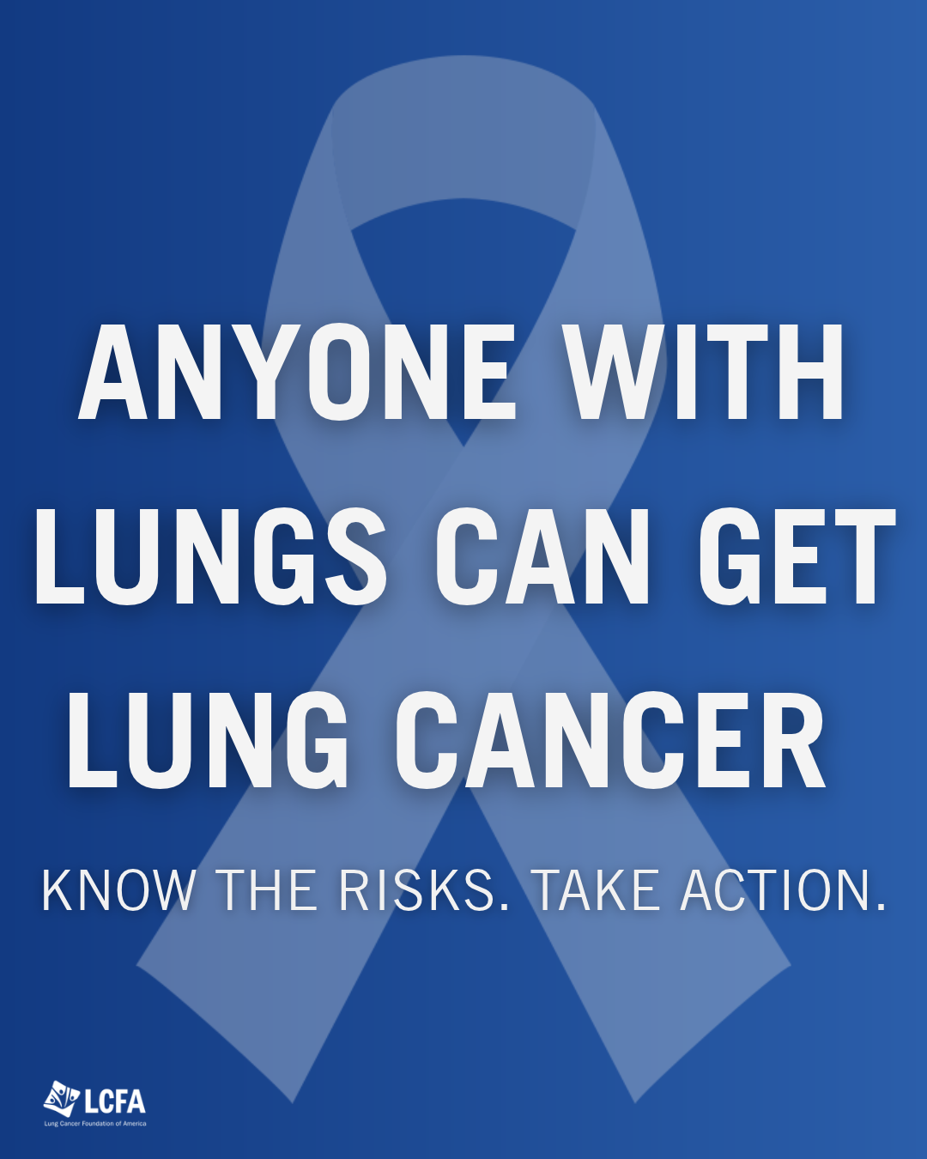 | Anyone with lungs can get lung cancer. 🫁  Age, lifestyle, and background don’t make anyone immune. Factors like radon, air pollution, and chemical exposure at work or at home all play a role, and early detection can change outcomes.  This Lung Cancer Awareness Month, we’re joining Lung Cancer Foundation of America to spread the word: if you’re at risk, talk to your doctor about screening.  Learn more: lcfamerica.org  #LungCancerAwarenessMonth #LungHealth #LungCancerAwareness #EarlyDetectionSavesLives
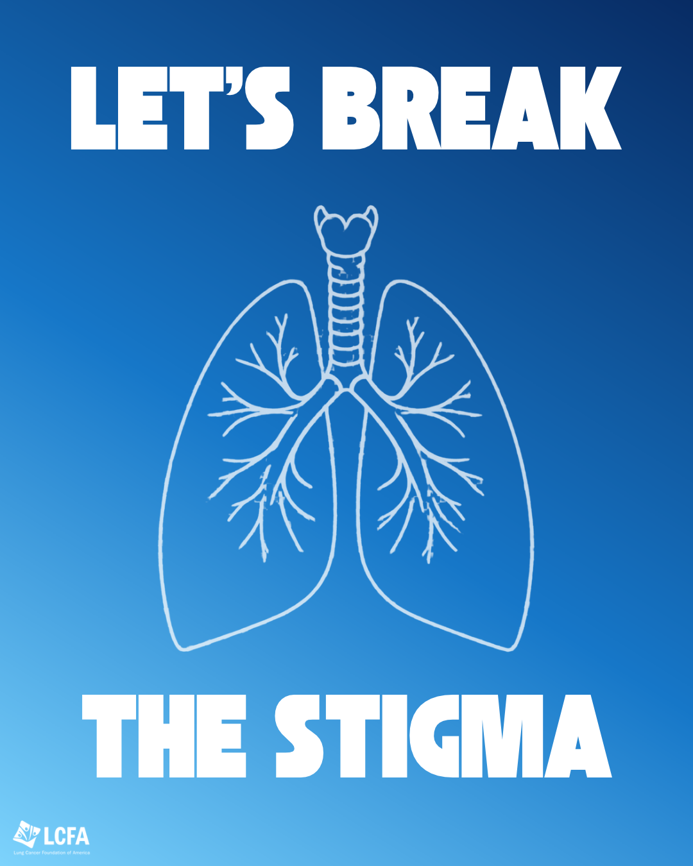 | Anyone with lungs can get lung cancer. 🫁  Yet stigma about smoking often makes it harder for patients to talk about their diagnosis or reach out for support. When the conversation focuses on blame, it pulls attention away from what matters most: awareness, early detection, and care.  This Lung Cancer Awareness Month, we’re joining Lung Cancer Foundation of America to help change the narrative. Learn how stigma affects patients and what you can do: lcfamerica.org  #LungCancerAwarenessMonth #LungCancerAwareness #EndTheStigma #EarlyDetectionSavesLives
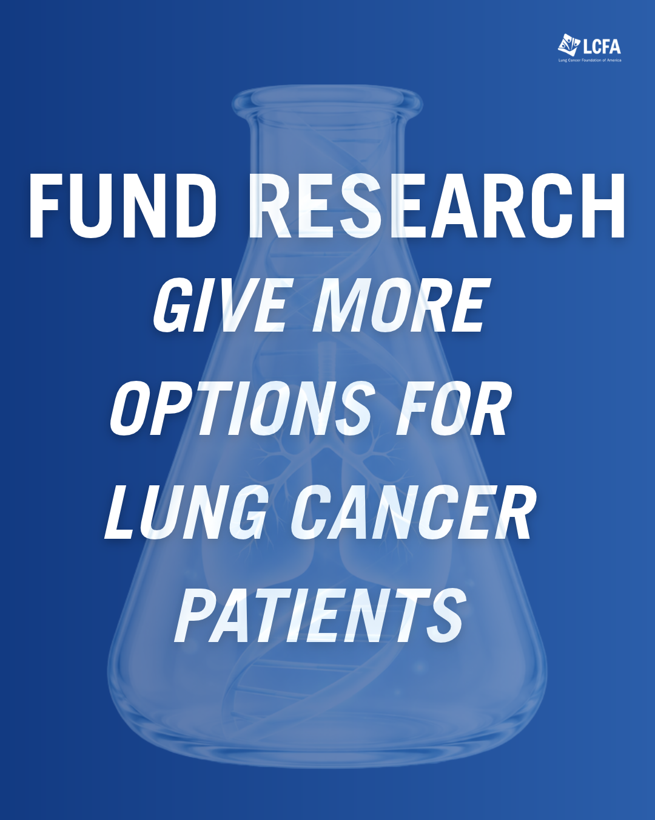 | Every new lung cancer treatment started with research. 🔬  Advances like targeted therapy, immunotherapy, and faster treatment delivery are giving patients options that didn’t exist a generation ago. But lung cancer remains the leading cause of cancer death in the U.S., and many patients still need better choices.  This Lung Cancer Awareness Month, we’re joining Lung Cancer Foundation of America in supporting the research that turns hope into new options for patients and families.  See the research Lung Cancer Foundation of America is funding: https://lcfamerica.org/lung-cancer-research/  #LungCancerAwarenessMonth #ResearchMatters #LungCancerAwareness

