2025 Lung Cancer Awareness Month

Sample posts – use these or create your own

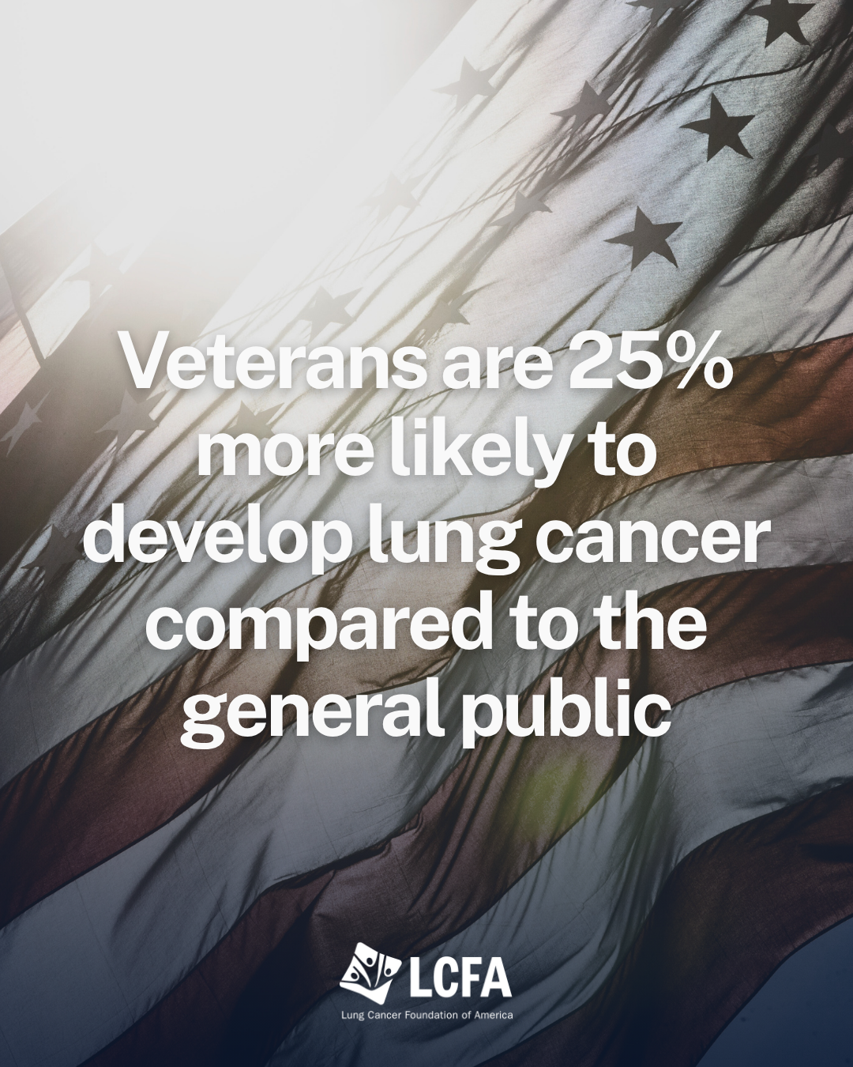 | Veterans who served our country face higher lung cancer risks due to burn pit exposure, asbestos, and other military hazards. The good news? Low-dose CT screening is available through the VA. Learn more about lung cancer awareness at lcfamerica.org. #VeteransHealth #LungCancerScreening #EarlyDetection
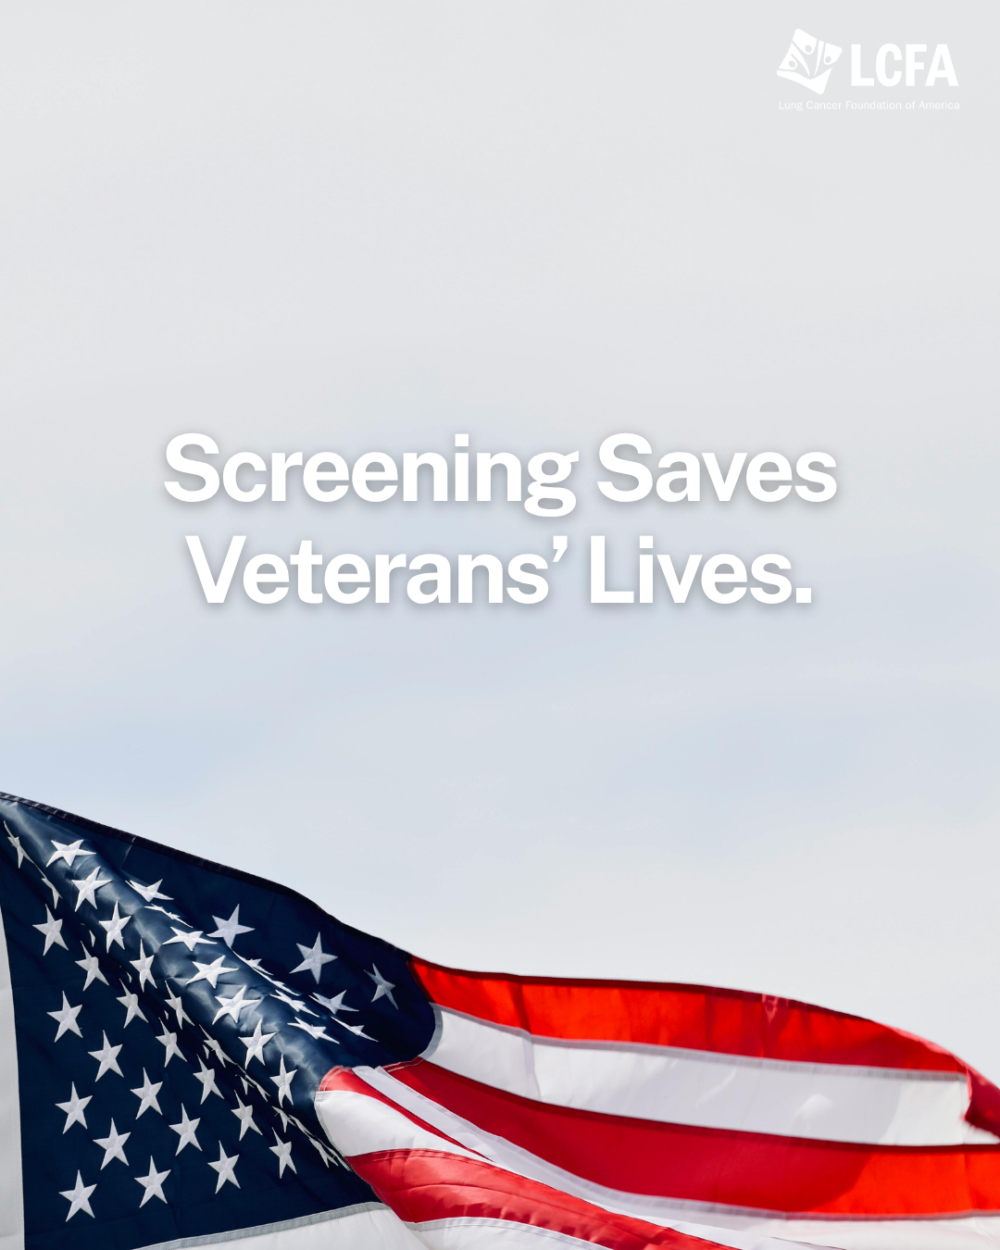 | Lung cancer screening is simple, fast, and can catch cancer early when it’s most treatable. Veterans, talk to your VA care team today about low-dose CT screening. Learn more about lung cancer awareness at lcfamerica.org. #VeteransHealth #LungCancerScreening #EarlyDetection
 | 🇺🇸 Did you know that 1.5 million Veterans are eligible for lung cancer screening? Early detection can make all the difference. Let’s ensure more Veterans have access to potentially life-saving screenings. 🎗️ Learn more about lung cancer awareness at lcfamerica.org. #VeteransHealth #LungCancerScreening #EarlyDetection
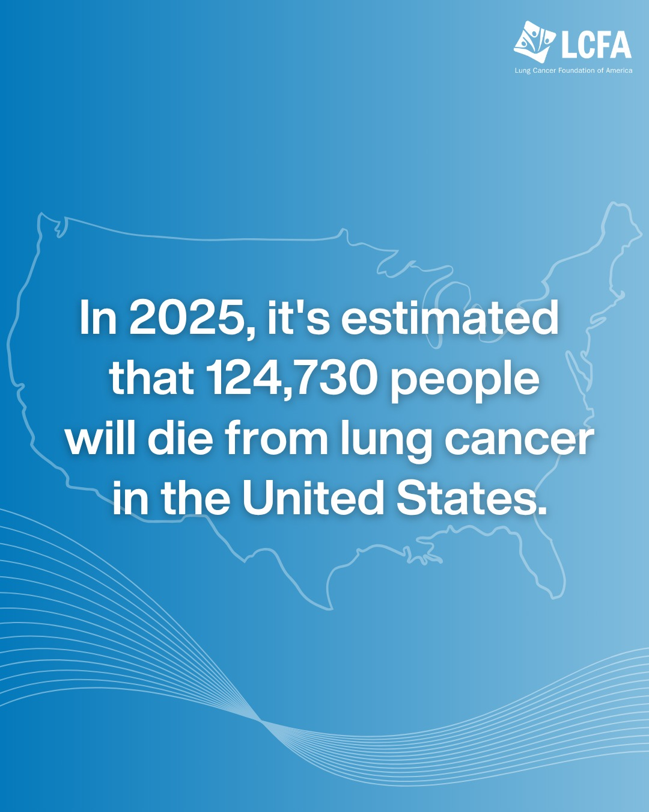 | In 2025, lung cancer is projected to kill 124,730 people in the U.S. That’s more deaths than any other cancer. This isn’t just a statistic—it’s a reflection of how far we still need to go in funding research, improving screening, and supporting patients. Learn more here: https://bit.ly/42dEmxA  #LungCancer #LungCancerAwareness #LCFA
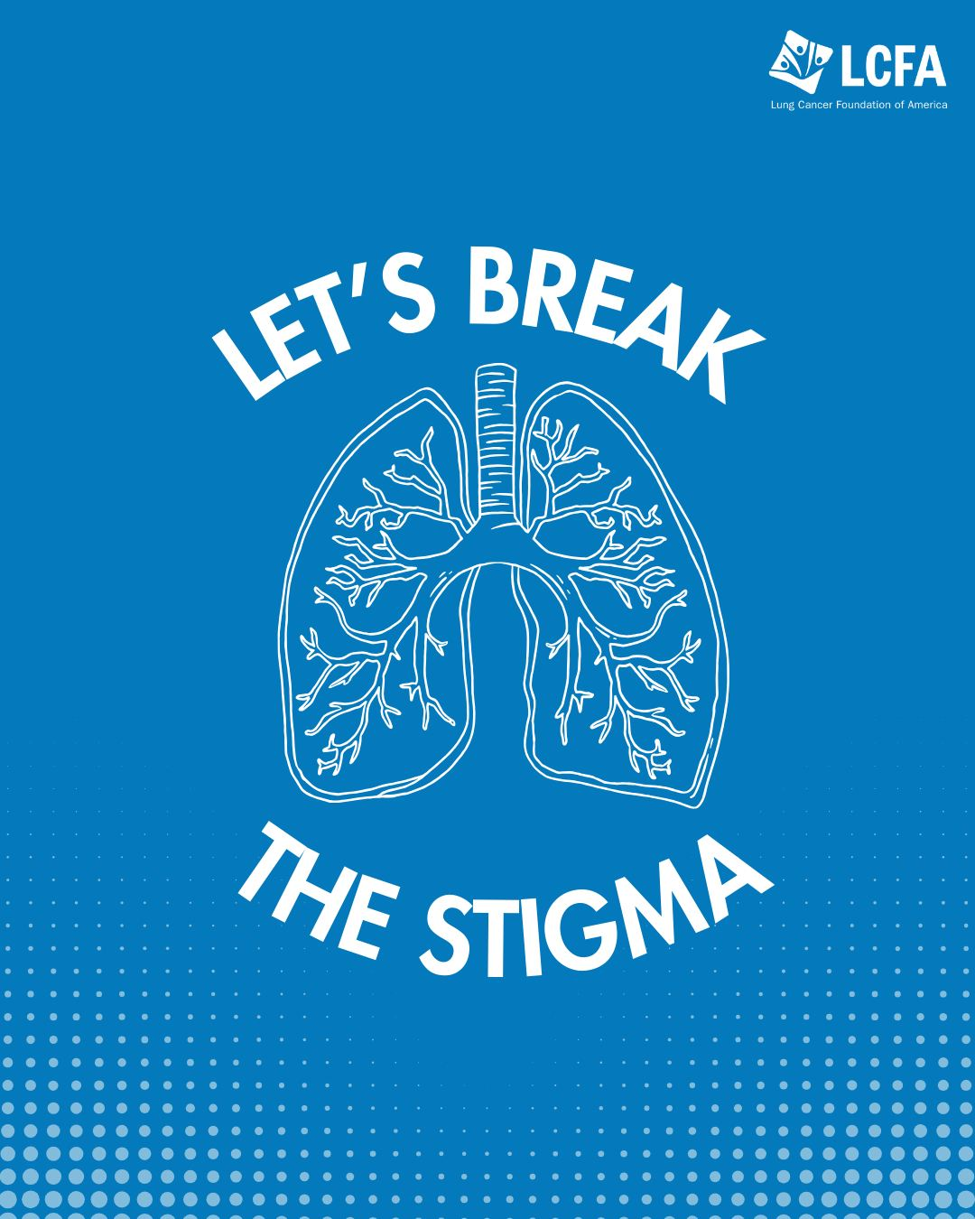 | Lung cancer stigma often makes it harder for patients to share their experiences and seek support. Assumptions about smoking can overshadow the fact that anyone with lungs can get lung cancer. Open conversations and accurate information help shift the focus to awareness and early detection. Learn more about how stigma impacts patients and what you can do to help change the narrative.
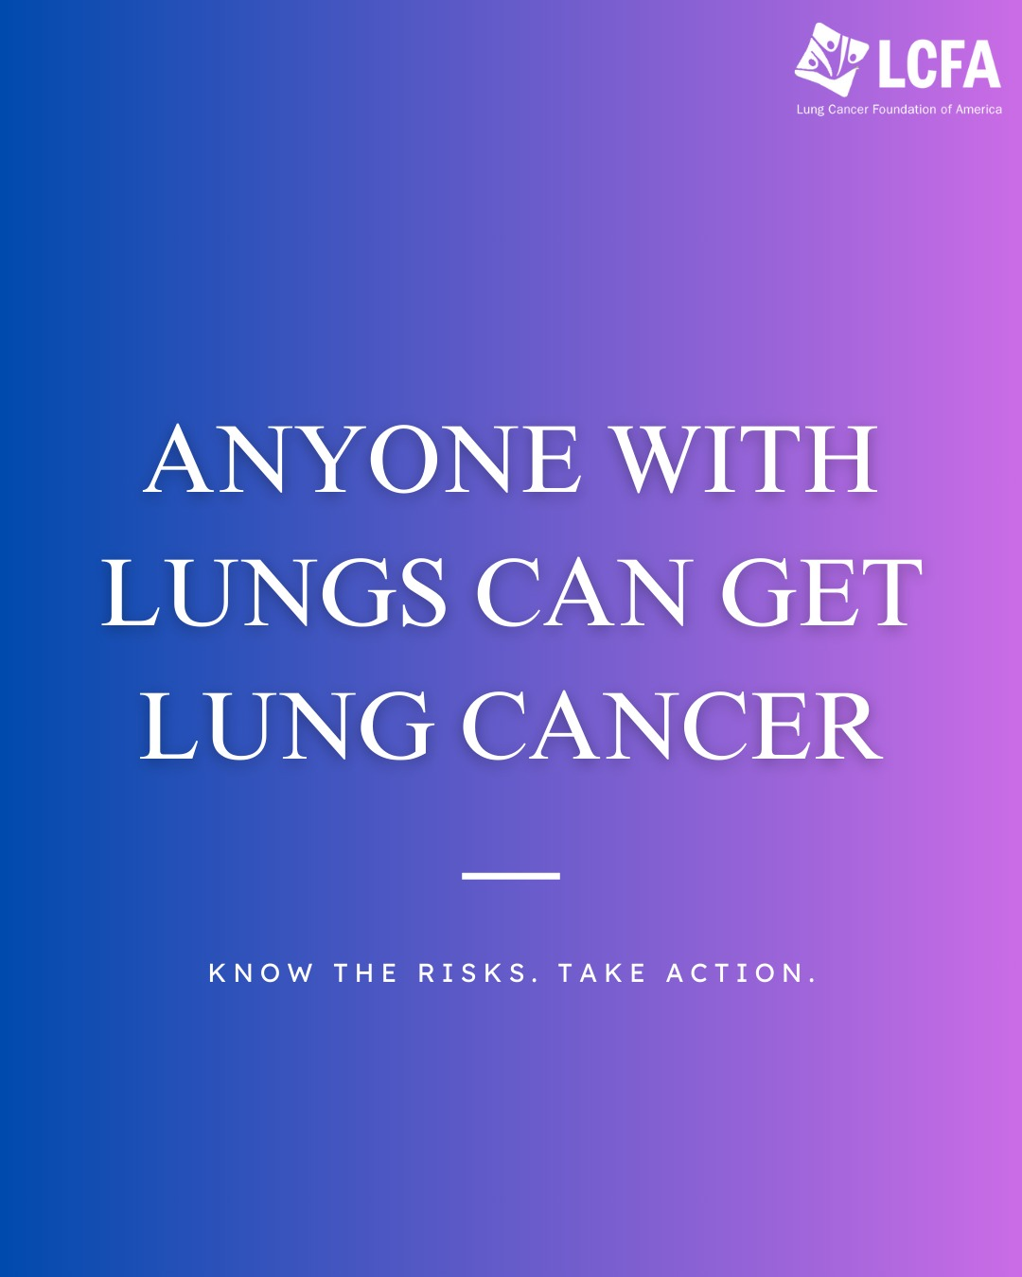 | Lung cancer can affect anyone, regardless of age, lifestyle, or background. Factors like radon, air pollution, and exposure to harmful chemicals all play a role. Early detection makes a difference.  If you’re at risk, talk to your doctor about lung cancer screening. Learn more at https://bit.ly/4bgvD1d  #LungHealth

