2024 Lung Cancer Awareness Month

Sample Facebook posts – use these or create your own!

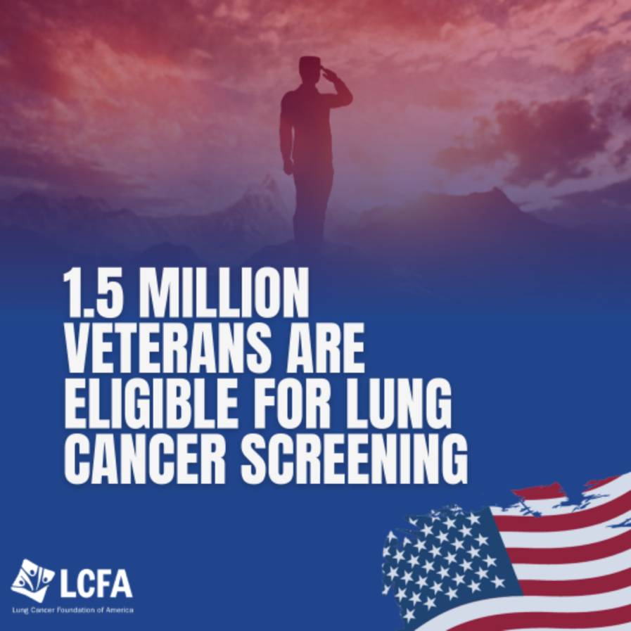 | 🇺🇸 Did you know that 1.5 million Veterans are eligible for lung cancer screening? Early detection can make all the difference. Let's ensure more Veterans have access to potentially life-saving screenings. 🎗️ Learn more about lung cancer awareness and supporting our heroes in the link below. #VeteransHealth #LungCancerScreening #EarlyDetection
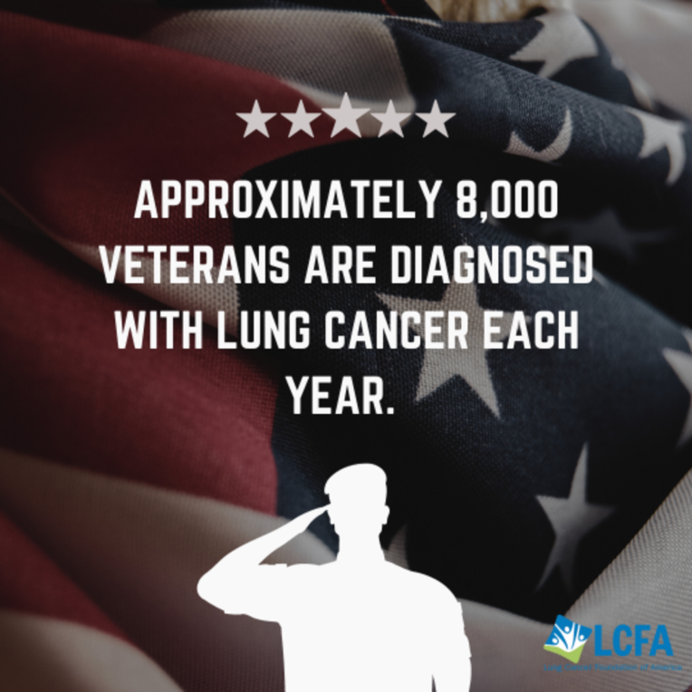 | 🇺🇸 Did you know that almost 8,000 Veterans are diagnosed with lung cancer each year? Lung cancer is one of the most prevalent and deadliest cancers among Veterans. Factors contributing to this may include a history of smoking, exposure to environmental hazards during or after military service, and age. Early detection can be a pivotal factor in improving outcomes for our Veterans. Don't wait - schedule your low-dose CT scan and take control of your future. #Veterans #LungCancer
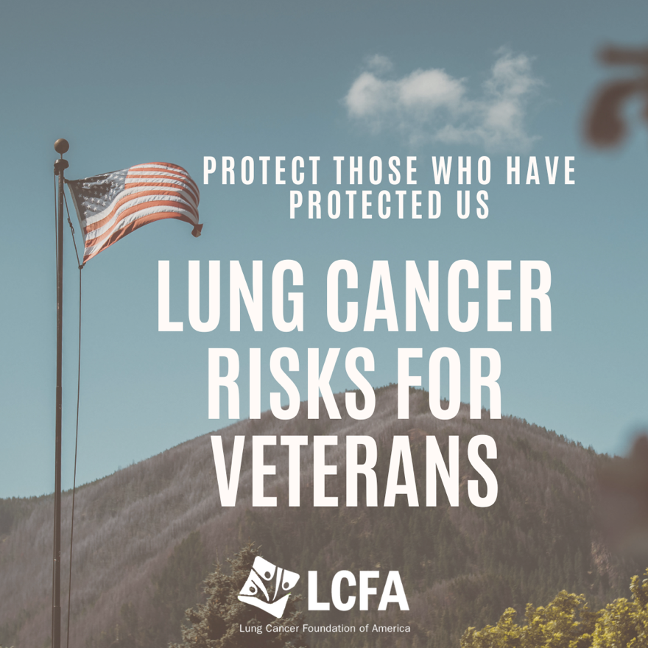 | 🇺🇸 Did you know that 1.5 million Veterans could be eligible for lung cancer screening? Early detection is key to saving lives. Let's make sure our heroes have access to these crucial screenings. 🎗️Learn more at lcfamerica.org  #VeteransHealth #LungCancerScreening #EarlyDetection
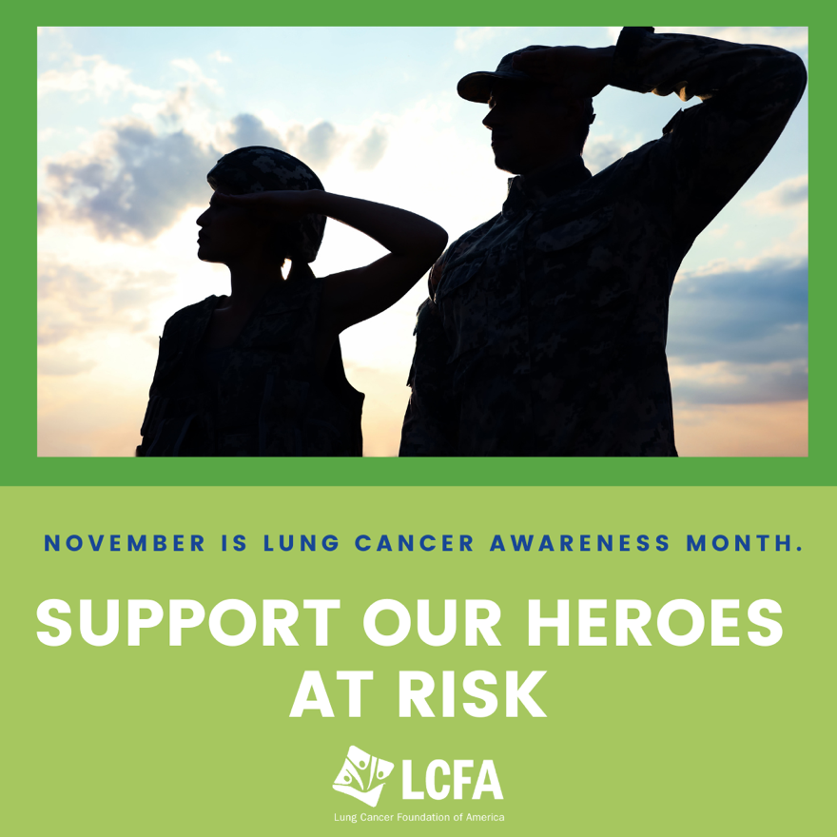 | Veterans, your service to our country has been invaluable, and now it's time to prioritize your health. With over 2.5 million currently serving personnel and 18.5 million Veterans who've dedicated their lives to our nation's defense we're here to support them.

