Personal Fundraising

Sample Tweets – use these or create your own!

#LungCancer is the biggest cancer killer in the United States every year. It kills more Americans than breast cancer, prostate cancer, and colorectal cancers - COMBINED. #382aDay. ReTweet to help raise #Awareness And, donate to my fundraiser!
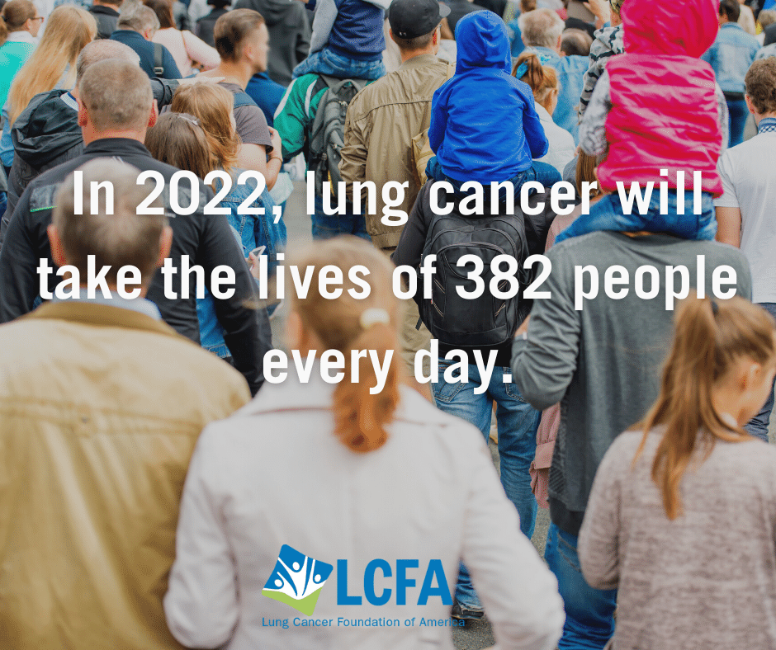

Don't believe the myth that only #smokers get #LungCancer. 1 out of every 5 new lung cancer patients either never #smoked or smoked fewer than 100 cigarettes in their lifetime. If you have lungs, you can get lung cancer. But, #ResearchSavesLives and you can help! Donate to my fundraiser and help save a life. https://bit.ly/3H6b0V4

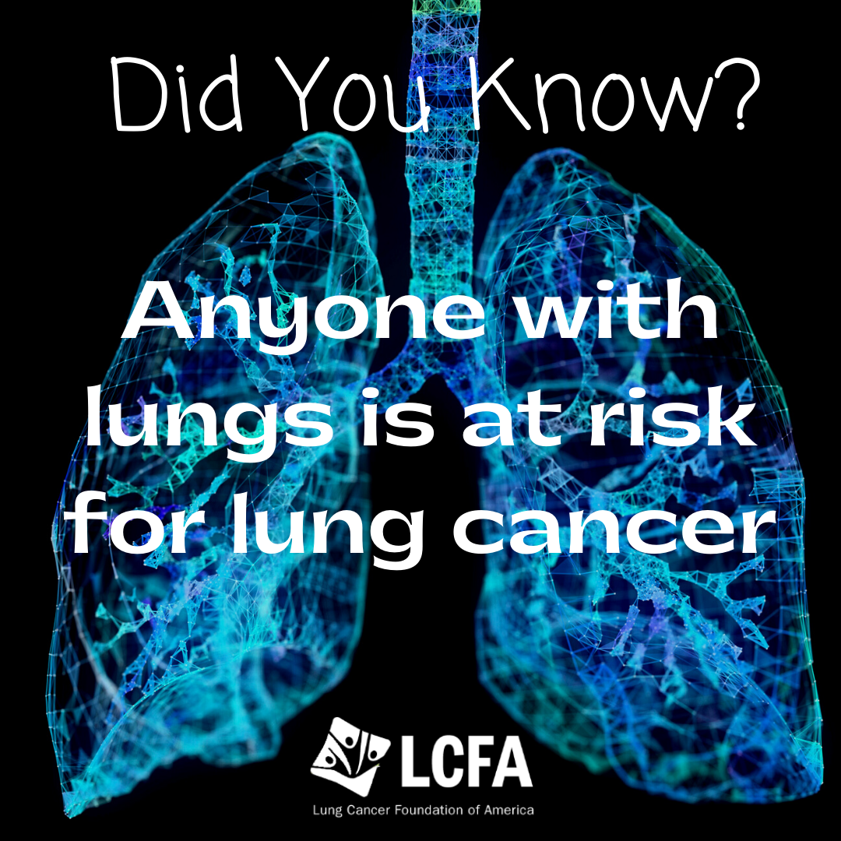

#LungCancer is the leading cause of cancer deaths in the US every year. 130,000+ people will die from lung cancer in 2022. Yet, Federal #Research funding lags behind. Help fix this disparity! Donate to my fundraiser!

