LCFA is celebrating #LivingWithLungCancer thanks to research this Lung Cancer Awareness Month

Sample Tweets – use these or create your own!

She never thought a persistent cough that lingered for months would be the beginning of her #lungcancer journey. But that is precisely what happened to Brandi Bryant, who is now #livingwithlungcancer after finding it harder to breath on walks. Read more: https://bit.ly/3NEkQBG

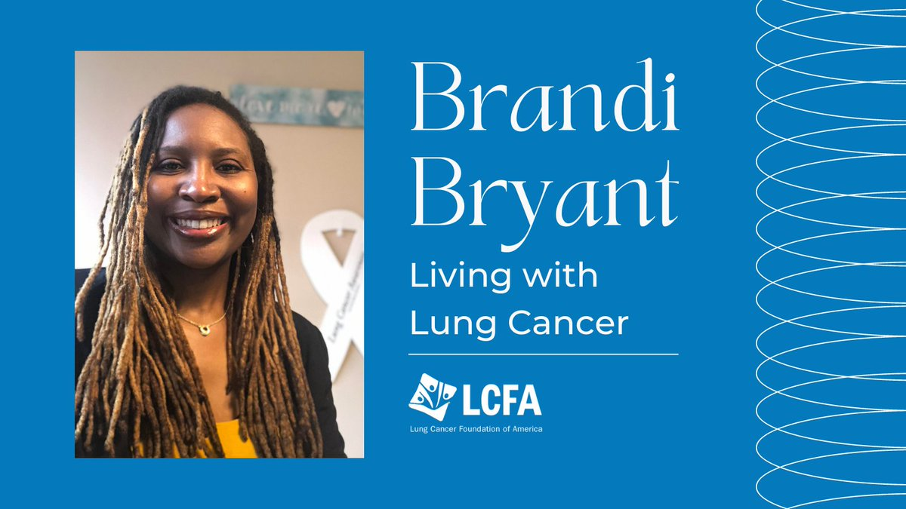

Those #LivingWithLungCancer understand the importance connecting with other patients and finding their community to strengthen their voice to advocate and give them hope. #LCAM22 https://bit.ly/2ScUi2q

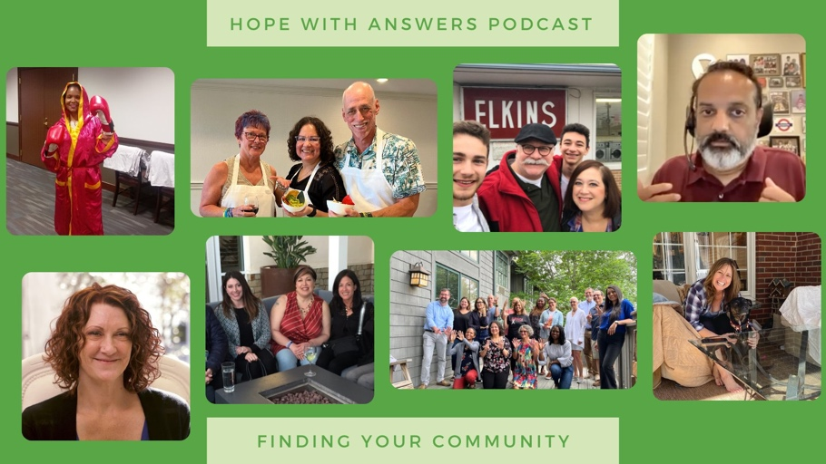

In recent years, more and more people who have never #smoked are developing #lungcancer. Check out why here: https://bit.ly/3o7dJpi

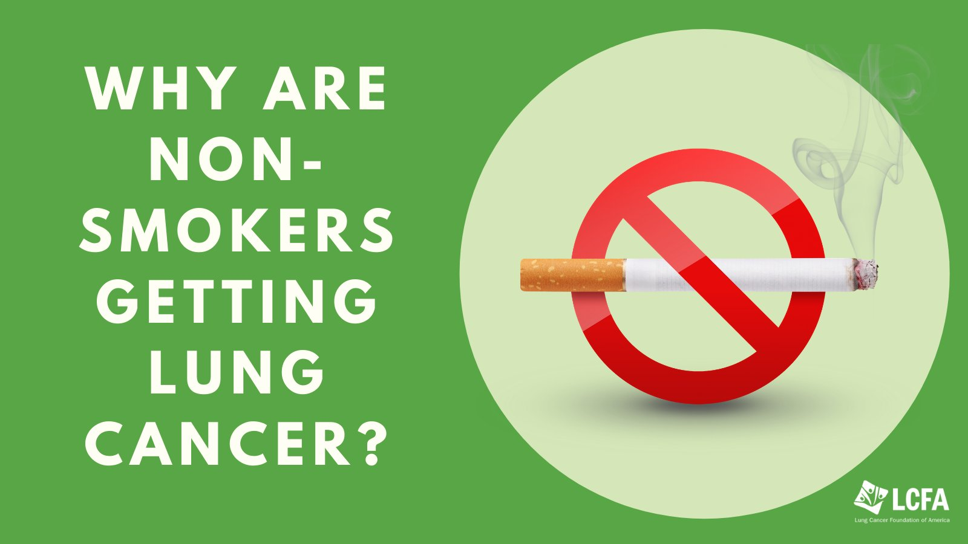

She is #livingwithlungcancer, @kRasKickers founder’s #diagnosis of #lungcancer was a bumpy one, but that wasn’t going to deter her. Learn more about our very own #KRAS rockstar, Terri Conneran here: https://bit.ly/2UxuUDs

