Lung Cancer Awareness Month

Sample Facebook posts – use these or create your own!

Lysa Buonanno has been #LivingWithLungCancer for more than 10 years. While Lysa does take an oral treatment that works for her #ROS1 biomarker, the addition of regular #chemotherapy is key to keeping Lysa's #LungCancer stable. Read Lysa's story! #LCFAmerica https://bit.ly/2vDxnz1

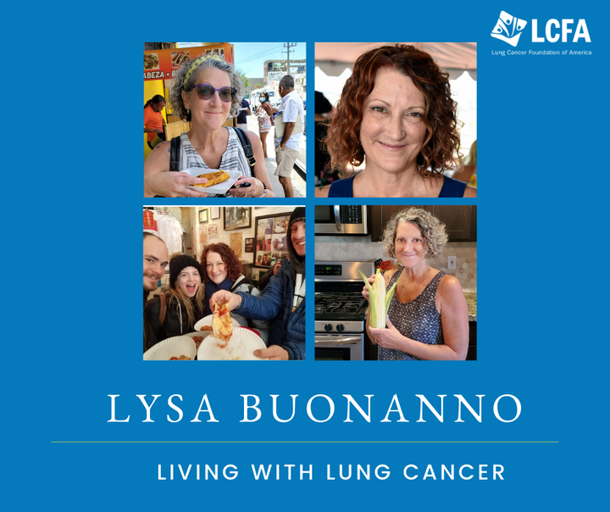

Tabitha was diagnosed with #LungCancer when she was 35. She is a teacher, a wife, and the mother of 2. Her diagnosis was #stage4 #adenocarcinoma with 29 brain metastases and the #ALK+ biomarker. Here's how she got from that diagnosis to be #LivingWithLungCancer with No Evidence of Disease (NED): https://bit.ly/2CmQcNm

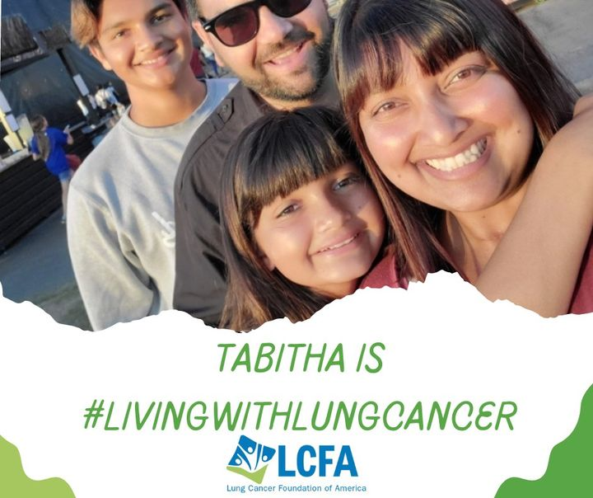

#LivingWithLungCancer is never easy, but connecting with other patient advocates can help newly-diagnosed patients harness the power of their own voice in treatment. Find your lung cancer family! https://bit.ly/2ScUi2q

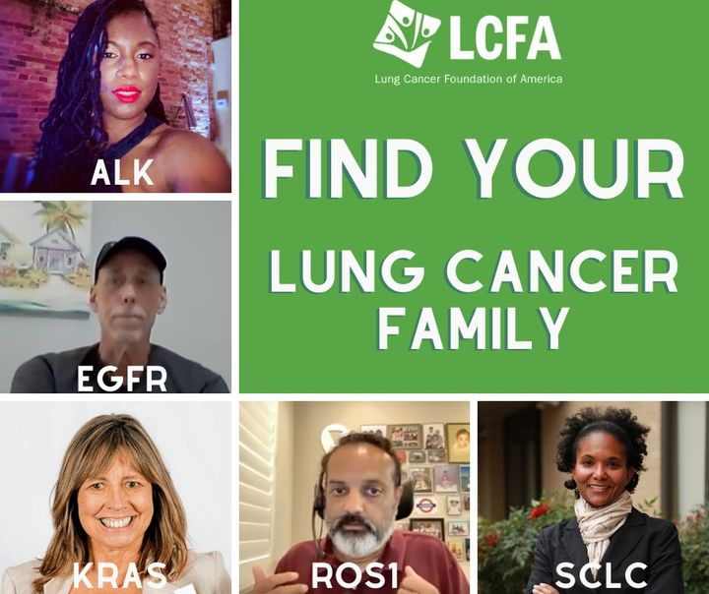

Recently diagnosed with lung cancer? Learn what questions to ask and how to ask them here: https://tinyurl.com/2bjy3raa

